7 Social Studies Name _________________________________
Historical Thinking Skills - Assessment

Your task: What do the following documents suggest about child labor at the end of the 18th century into the 19th century? Analyze 3 documents to determine how working at a young age affected children. As we have been doing in class, analyze each document in terms of source, context, corroboration, and close reading. Look back at your notes for these vocabulary terms, and think about what we have discussed as we’ve looked at pictures. Do the sources give you a balanced perspective about the effects of child labor? Organize your thoughts into a detailed, well organized essay,

Document A - from the journal of Rhys Evans whose father and other ancestors worked in coal mines

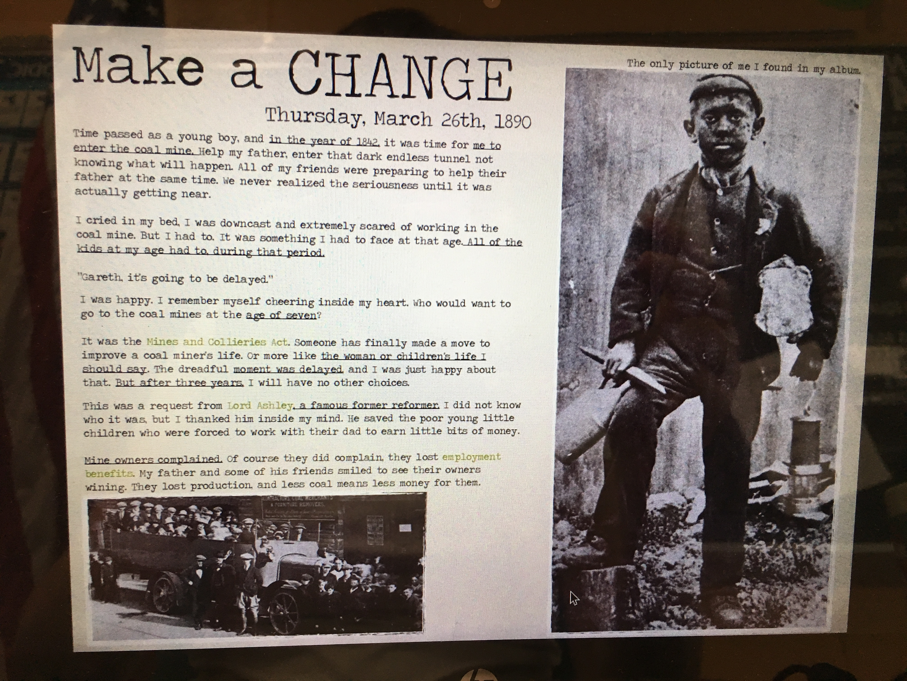

Document B

Document C
John Fielden, a factory owner, admitted that a great deal of harm was caused by the children spending the whole day on their feet: " At a meeting in Manchester a man claimed that a child in one mill walked twenty-four miles a day. I was surprised by this statement, therefore, when I went home, I went into my own factory, and with a clock before me, I watched a child at work, and having watched her for some time, I then calculated the distance she had to go in a day, and to my surprise, I found it nothing short of twenty miles." (11)
Rubric for essay (25 points)
- Organization of content into paragraphs that make sense (max of 3 points)
- Each source is evaluated for source, context, corroboration, and close reading (max of 10 points)
- You wrote your opinion of child labor based on these documents (max of 10 points)
- Appropriate grammar and spelling (max of 2 points)

Due 9/20/18

Please utilize Google Docs. When you have finished, share it with Mrs. Judson (Ljudson@olvmd.org). When you share it, make sure she can comment on it. Use your school Gmail account, not your personal email account.

